Roadmap
This structured, step-by-step roadmap will take you from installation to writing your own programs.
Contents
Phase 1- Set Up Your Tools 2
1. Coding Pack for Java - Setting up Visual Studio Code for Java development 2
2. Git and GitHub 2
Phase 2 - First java code in IDE 5
Phase 3 – Data types, Variables 8
Primitive DataType 8
Variables 9
3. Reserved Words 10
Phase 4 – Data representation 11
1. Data Representation 11
2. Bit and Byte 12
3. Internal representation - Bit numbering and value 12
4. Range of 1 byte 14
5. 1-byte character example 15
6. Word and Double word 16
7. Number system. 17
Base-10: 17
Base-2: 17
Hexa-decimal number (Base-16): 18
Conversion between number system 19
Phase 4 - Working with Git and Bash commands - Local Repo 20
How do I get my code on Github 23
Option 1 24
Option 2 - Git clone 25

Phase 1- Set Up Your Tools
- Before writing code, you need an environment to run it.
- Oracle Java Development Kit (JDK)
- Integrated Development Environment (IDE)
- Git version control tool
- GitHub account setup.

Coding Pack for Java - Setting up Visual Studio Code for Java development
Follow the link to download and install Coding Pack for Java
1> Video link: https://www.youtube.com/watch?v=tYYVeCB7Ef4
2> Download and install from: https://code.visualstudio.com/docs/java/java-tutorial#_setting-up-vs-code-for-java-development
3> Tutorial for using VS Code: https://www.youtube.com/watch?v=bj6QSx22zXs
4> Java for Beginners complete 2 hours tutorial: https://www.youtube.com/watch?v=o33cQL6-2Sg&t=19s
5> https://code.visualstudio.com/docs/java/java-tutorial

Git and GitHub
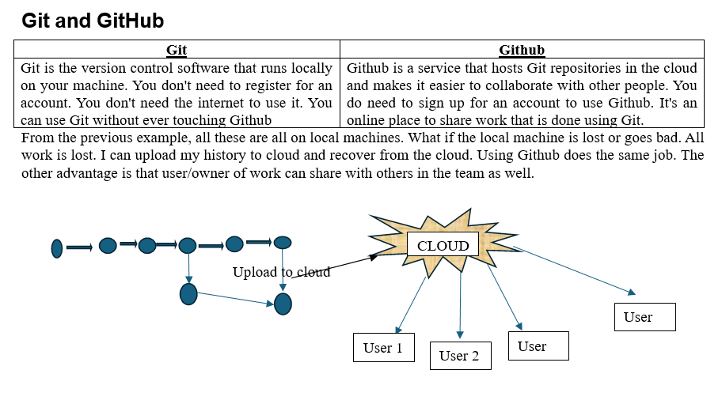
Where Do We Start?
Below are the steps to set up Git and GitHub
- Install Git
- Create a local repository
- Connect to the remote repository
- Push the file to GitHub
- Basic Git commands
1> Signing up for a new personal GitHub account
- Navigate to https://github.com/.
- Click Sign up.
- Alternatively, click on Continue with Google to sign up using social login.
- Follow the prompts to create your personal account.
During signing up, you'll be asked to verify your email address. Without a verified email address, you won't be able to complete some basic GitHub tasks, such as creating a repository.
Getting started: https://docs.github.com/en/get-started/start-your-journey/creating-an-account-on-github
Tutorial: How to Create a GitHub Account : https://www.youtube.com/watch?v=RnWDKWmaQ8s

2> Download and install: Git and Git Bash command line interface.
Download and install: https://git-scm.com/
Tutorial to install Git: https://www.youtube.com/watch?v=tRZGeaHPoaw
Getting started: https://docs.github.com/en/get-started/learning-to-code/getting-started-with-git
Working with Git and GitHub: https://www.youtube.com/watch?v=d3FkIA9RtlA

OR

2> Download and install: GitHub Desktop Client
Instead of using Git from command line, GitHub Desktop Client allows us to use Git from graphical interface. If you have GitHub Desktop installed, you can use it to clone repositories and not deal with SSH keys.
Download and install: https://github.com/apps/desktop
Tutorial link: https://www.youtube.com/watch?v=8Dd7KRpKeaE
https://www.youtube.com/watch?v=MaqVvXv6zrU
Getting started: https://docs.github.com/en/get-started/learning-to-code/getting-started-with-git#learning-git-basics-with-github-desktop

Git Is (Primarily) A Terminal Tool Git was created as command-line tool. To use it, we run various git commands in a Unix shell. This is not the most user-friendly experience, but it's at the very core of Git!
How to get Git Bash in GitHub Desktop?
To get and use Git Bash inside GitHub Desktop, you need to download Git for Windows separately and then select it as your default shell inside the GitHub Desktop settings.
Follow this quick setup process to link them together:
Step 1: Install Git Bash on Your PC
- Go to the official Git for Windows Download Page.
- Click Download to get the installer package.
- Run the downloaded installer file (.exe).
- Click Next through the setup prompt windows to accept the default settings, then click Install.
Step 2: Set Git Bash as Default in GitHub Desktop
- Open your GitHub Desktop client.
- In the top-left menu bar, click on File and select Options (on Mac, click GitHub Desktop > Settings).
- Click on the Integrations tab on the left sidebar.
- Look for the Shell dropdown menu.
- Select Git Bash from the list of available terminal choices.
- Click Save to apply the configuration.
Step 3: Open Git Bash Instantly
Once configured, you can launch Git Bash directly from your active project repository using either of these quick methods:
- The Shortcut: Press `Ctrl + `` (Control + Backtick) on your keyboard.
- The Menu: Click on Repository in the top menu bar, then click Open in Git Bash.

Phase 2 - First java code in IDE
- Create java project or standalone java extension file
Standalone java File
How to create standalone java in VSCode: https://code.visualstudio.com/docs/java/java-tutorial#_creating-a-source-code-file
- Use this when you want to write a quick loop or test a piece of logic.
- You do not need any special configuration or folders.
- You cannot easily link it to other Java files.

Java Project
Follow link to create java project: https://www.youtube.com/watch?v=tYYVeCB7Ef4
- Use this when your program needs multiple files working together.
- It keeps your source code (src) separate from your compiled code (bin).
- It allows you to organize your files into packages (folders) as your code grows.
To create a Java project in VS Code, use the built-in Java project wizard.
Step-by-Step Setup
- Open Command Palette: Press Ctrl + Shift + P (or Cmd + Shift + P on Mac).
- Launch Wizard: Type Java: Create Java Project and select it from the list.
- Select Project Type: Choose No build tools for a simple project (or select Maven/Gradle for advanced projects).
- Choose Location: Select the folder where you want to save your project files.
- Name Project: Input a name for your project folder and press Enter.

What Gets Created
VS Code automatically generates a standard folder structure for you.
- src/: The folder where you will write all your .java source code files.
- lib/: The folder to drop external libraries or .jar dependencies.
- App.java: A starter file containing a default "Hello, World!" program.
How to Run Your Project
- One-Click Run: Open App.java and click the Run button that appears directly above the main method.
- Shortcut: Press F5 on your keyboard to compile and debug the active file instantly

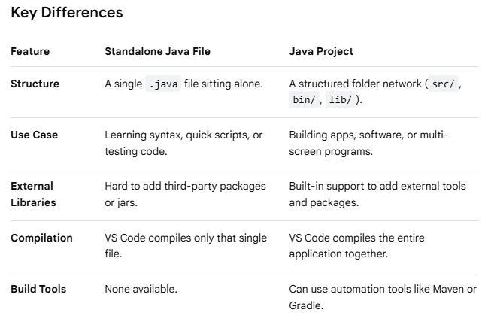
- Understand starting point of Java program
public class Main {
public static void main(String[] args) {
System.out.println("Hello, World!");
}
}
Breakdown of the Code
- public class Main: Creates a container for your code. The class name must match your file name (e.g., Main.java).
- public static void main: The starting point (entry gate) where Java begins executing your program.
- System.out.println(): The built-in command used to print text out to the screen

Compile the code: Type javac Main.java and press Enter to convert your code into machine-readable bytecode.
Execute the program: Type java Main and press Enter to see your message print to the console.
Or
Run from VSCode

The public static void main(String[] args) line is the exact entry point for every Java application. When you run a Java program, the Java Virtual Machine (JVM) looks specifically for this exact sequence of words to start executing your code. If any part of it is missing or misspelled, your program will not start.
Here is a breakdown of what every single word in that line means:
public: Meaning: Accessible to everyone.
Why it is needed: The JVM is external to your specific code program. It needs public permission to see, access, and trigger this starting method from the outside.
static: Meaning: Belongs to the class, not an object.
Why it is needed: Normally, to run a method in Java, you have to create an "instance" (an object) of that class first. Because this is the absolute start of the program, no objects exist yet. static allows the JVM to run this method instantly without needing to create an object first.
void: Meaning: Returns nothing.
Why it is needed: Functions can calculate a value and hand it back to whoever called them. The main method simply executes your program instructions and finishes; it does not return any final data value back to the computer system.
main: Meaning: The method identifier name.
Why it is needed: This is a strictly reserved word in Java. You can name other methods whatever you want, but the initial starting gate must be named exactly main for the JVM to locate it.
String[] args: Meaning: Command-line arguments.
Why it is needed: This acts as an empty basket that accepts text inputs when you boot up the program from a terminal (e.g., typing java Main input1 input2). The [] means it is a list (array) of words, and args is just the short name for arguments

The Java Virtual Machine (JVM) is an abstract computing machine that enables a computer to run Java programs. It acts as an intermediary runtime engine that sits between your Java code and the underlying computer hardware and operating system.
The Core Concept: "Write Once, Run Anywhere"
In traditional languages like C++, code is compiled directly into machine instructions tailored to a specific operating system (like Windows or macOS).
Java handles this differently:
- You write Java source code (.java file).
- The Java compiler (javac) converts your text into a universal intermediate form called Bytecode (.class file).
- The JVM reads this bytecode and translates it on the fly into the specific machine code your current computer understands.
Because every operating system has its own specific version of the JVM, the exact same bytecode file can run on Windows, Mac, Linux, or a smartphone without any changes to the original source code

Phase 3 – Data types, Variables

Primitive DataType
Data types in Java specify the size and type of values that a variable can store. Java is a strongly typed language, meaning every variable must be declared with a specific data type before it can be used.
Java data types are divided into two main categories: Primitive and Non-Primitive.

Numeric Types (Integers): Used to store whole numbers without decimals.
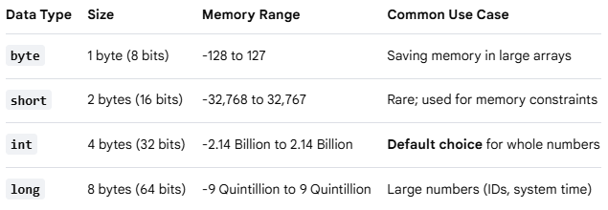
Note: When assigning a value to a long, append an L or l to the end of the number (e.g., long population = 8000000000L;)
Numeric Types (Floating-Point): Used to store fractional numbers containing decimals.
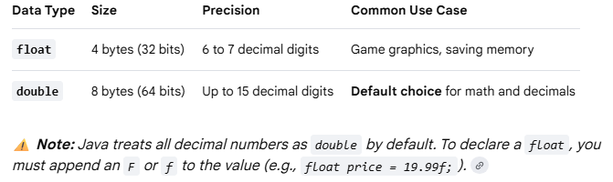
Character Type: Used to store a single character.
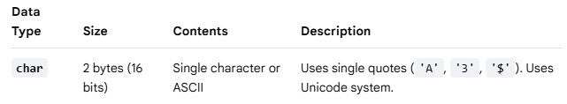
Boolean Type: Used to store conditional states.
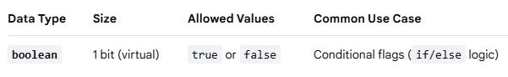

Variables
A variable is a named storage container in a computer's memory used to hold data that a program can manipulate and change during execution. Think of it as a labeled box on a shelf; the label is the variable's name, and the item inside the box is its value.

The Three Rules of Java Variables
Because Java is strongly typed, every variable must follow a strict three-part declaration syntax:
- Type: What kind of data can fit inside the box (e.g., int, double, String).
- Name: The identifier used to call upon that specific box in your code (e.g., age, price).
- Value: The actual data stored inside the box (e.g., 25, 19.99).

Variable Syntax and Examples
You create a variable by declaring its type and name, and you populate it by initializing it with an assignment operator (=).
// 1. Declaration only (Creating the empty box)
int score;
// 2. Initialization (Putting a value into the box)
score = 10;
// 3. Combined Declaration and Initialization (Most common)
String username = "Alex";
// 4. Changing the value later (Overwriting the box contents)
score = 15;

Variable Scopes in Java
Where you declare a variable determines where it can be used inside your code:
- Local Variables: Declared inside a method (like main). They only exist while that specific method is running and cannot be accessed from outside it.
- Instance Variables: Declared inside a class but outside any methods. They belong to objects created from the class.

- Static Variables: Declared with the static keyword inside a class. They belong to the class itself and are shared globally across all instances.

Rules for Naming Variables (Identifiers)
- Names are case-sensitive (age and Age are completely different boxes).
- Names must start with a letter, a dollar sign ($), or an underscore (_). They cannot start with a number.
- Names cannot contain spaces.
- Names cannot use Java reserved keywords (you cannot name a variable public or class).
- Java convention uses camelCase for multi-word names

Reserved Words
Reserved words (also known as keywords) are predefined words that have a special, built-in meaning to the Java compiler. Because the language reserves these words for its own structural rules, logic, and commands, you cannot use them as names for your variables, classes, methods, or any other identifiers.
Java has over 50 reserved words. They are always written in lowercase.
Categories of Common Reserved Words
1. Data Types & Values
Words used to declare variable types or literal states.
- int, double, char, boolean, long, float, byte, short: Define primitive data types.
- true, false: Literal boolean values.
- null: Represents an empty or non-existent reference.
2. Access Modifiers
Words that control which parts of your program can see or use a class, method, or variable.
- public: Accessible from anywhere in your project.
- private: Accessible only inside the specific class where it was created.
- protected: Accessible within the same package or by child classes.
3. Flow Control & Logic
Words that dictate the order in which your code runs.
- if, else: Used to make conditional decisions.
- switch, case, default: Used for multi-way branching selections.
- for, while, do: Used to create loops that repeat code blocks.
- break: Exits a loop or switch block immediately.
- continue: Skips the rest of the current loop iteration and moves to the next one.
- return: Exits a method and optionally sends back a value.
4. Program Structure & Modifiers
Words used to build and organize the layout of your application.
- class: Declares a new object blueprint.
- interface: Declares a structural contract for classes.
- package: Groups related classes together into a folder system.
- import: Brings external classes or packages into your current code file.
- static: Attaches a method or variable directly to the class rather than an object instance.
- void: Tells a method that it will not return any data.
- final: Makes a variable constant (unchangeable) or prevents a class from being inherited.
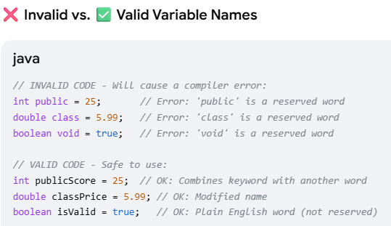

Phase 4 – Data representation
References:
1> https://www.techtarget.com/searchstorage/definition/byte
2> https://web.stanford.edu/class/cs101/bits-bytes.html
Video: https://www.youtube.com/watch?v=KLR5Y2uBYng

1. Data Representation
Computers are electronic devices that stores voltages. These devices are either ON or OFF. Thus only 2 voltages are possible, 1 for ON and 0 for OFF. Thus computer stores information (data) as two symbols ie 0 and 1.

The most important concept is to understand the difference between a number and the data that represents it. A number is an abstract concept, such as a count of something. You have ten fingers. The idea of "ten" doesn't change, no matter what representation you use.
Data is a physical concept, a raw sequence of bits and bytes stored on a computer. Data has no inherent meaning and must be interpreted by whoever is reading it. Computers store data using a sequence of 1's and 0's. Later, they read back the 1's and 0's and try to recreate the abstract concept from the raw data. Depending on the assumptions made, the 1's and 0's can mean very different things.

2. Bit and Byte
Everything on a computer is 0's and 1's. The bit stores just 0 or 1: it's the smallest building block of storage. On the smallest scale on the computer, information is stored as bits and bytes.
Bit | Byte
- a "bit" is atomic: the smallest unit of storage  - A bit stores just a 0 or 1  - "In the computer it's all 0's and 1's" ... bits  - Anything with two separate states can store 1 bit  - In a chip: electric charge = 0/1  - In a hard drive: spots of North/South magnetism = 0/1  - A bit is too small to be much use  - Group 8 bits together to make 1 byte | - In coding, a byte is a unit of digital information that is made up of eight bits.  - One byte = collection of 8 bits  - e.g. 0 1 0 1 1 0 1 0  - One byte can store one character, e.g. 'A' or 'x' or '$'  - The unit symbol for the byte is the upper-case character B.
It is the smallest unit of memory that can be addressed in many computer architectures.
Storing Numbers as Data
The internal representation of any data in computer is a string of bits (binary number).

3. Internal representation - Bit numbering and value
Bit numbering is bit positions in a binary number. The bit number starts with zero and is incremented by one for each subsequent bit position.
In “LSB 0” numbering scheme, the bit number starts with zero, for the least significant bit.
In “MSB 0” numbering scheme, the bit numbering starts at zero for the most significant bit.
The value of the number is calculated by using exponentiation with the bit number and a base of 2.

LSB 0: 8-bit binary number with least significant bit assigned the bit number 0
Bit position | Bit -7 | Bit-6 | Bit-5 | Bit-4 | Bit-3 |  | Bit-2 | Bit-1 | Bit-0
Binary number | MSB | 0 | 0 | 1 | 0 |  | 1 | 1 | LSB
Binary number | 1 |  |  |  |  |  |  |  | 0
Convert base-2 to base-10(decimal) | 1x2⁷  = 128 | 0x2⁶  = 0 | 0x2⁵  = 0 | 1x2⁴  = 16 | 0x2³  = 0 |  | 1x2²  = 4 | 1x2¹  = 2 | 0x2⁰  = 0
Value(decimal) | 150

MSB 0: 8-bit binary number with most significant bit assigned the bit number 0
Bit position | Bit-0 | Bit-1 | Bit-2 | Bit-3 | Bit-4 |  | Bit-5 | Bit-6 | Bit-7
Binary number | MSB | 0 | 0 | 1 | 0 |  | 1 | 1 | LSB
Binary number | 1 |  |  |  |  |  |  |  | 0
Convert base-2 to base-10(decimal) | 1x2⁰  = 1 | 0x2¹  = 0 | 0x2²  = 0 | 1x2³  = 8 | 0x2⁴  = 0 |  | 1x2⁵  = 32 | 1x2⁶  = 64 | 0x2⁷  = 0
Value(decimal) | 105

These bits are grouped as
- Nibble (4 bits): A nibble is a sequence of 4 bits
- Byte (8 bits): A byte is a sequence of 8 bits. The term byte initially meant ‘the smallest addressable unit of memory’.
- Word (16 bits)
- Double word (32 bits)

Bits are numbered from right-to-left. Bit 0 is the rightmost and the smallest; bit 7 is leftmost and largest.
The "leftmost" bit in a byte is the biggest.
The binary sequence 00001001 is decimal number 9. 00001001 = 9.
 | Bit 7 | Bit 6 | Bit 5 | Bit 4 | Bit 3 | Bit 2 | Bit 1 | Bit 0
binary sequence | 0 | 0 | 0 | 0 | 1 | 0 | 0 | 1
polynomial evaluation with power of 2 | 0x2⁷ | 0x2⁶ | 0x2⁵ | 0x2⁴ | 1x2³ | 0x2² | 0x2¹ | 1x2⁰
polynomial evaluation with power of 2 | 0 | 0 | 0 | 0 | 8 | 0 | 0 | 1
Decimal number | 9

4. Range of 1 byte
The range of 1byte(8bits) is explained below
If all 8 bits of 1-byte are 0(as show below), calculating the value results in minimum value of 0x00.
If all 8 bits of 1-byte are 1(as show below), calculating the value results in maximum value of 0xff.
So the range of number that can be stored in 1byte is 0x00 to 0xff.
8-Bits (1byte) | 0 | 0 | 0 | 0 | 0 | 0 | 0 | 0
polynomial evaluation with power of 2. | 0*2⁷  = (0) | 0*2⁶ = (0) | 0*2⁵ = (0) | 0*2⁴ = (0) | 0*2³ = (0) | 0*2² = (0) | 0*2¹ = (0) | 0*2⁰ = (0)
Decimal value | 0
Hexadecimal value | 0x00
figure-1: Minimum value of 1 byte

8-Bits (1byte) | 1 | 1 | 1 | 1 | 1 | 1 | 1 | 1
polynomial evaluation with power of 2. | 1*2⁷ = (128) | 1*2⁶ = (64) | 1*2⁵ = (32) | 1*2⁴ = (16) | 1*2³ = (8) | 1*2² = (4) | 1*2¹ = (2) | 1*2⁰ = (1)
Decimal value | 255
Hexadecimal value | 0xFF
figure-2: Maximum value of 1 byte.

One Byte - 256 Patterns conclusion from above
- 1 byte is group of 8 bits.
- 8 bits can make 256 different patterns.
- How to use the 256 patterns?
- How to store a number in a byte?
- Start with 0, go up, one pattern per number, until run out of patterns.
- 0, 1, 2, 3, 4, 5, ... 254, 255
- One byte can hold a number between 0 and 255.
- i.e. with 256 different patterns, we can store a number in the range 0...255
- Really good for storing characters/letters.

5. 1-byte character example
- 1 byte is enough to hold about 1 typed character, e.g. 'b' or 'X' or '$'.
- ASCII is an encoding representing each typed character by a number.
- ASCII is an encoding representing each typed character by a number.
- All characters in keyboard are assigned with pre-defined number as shown in this ASCII table.
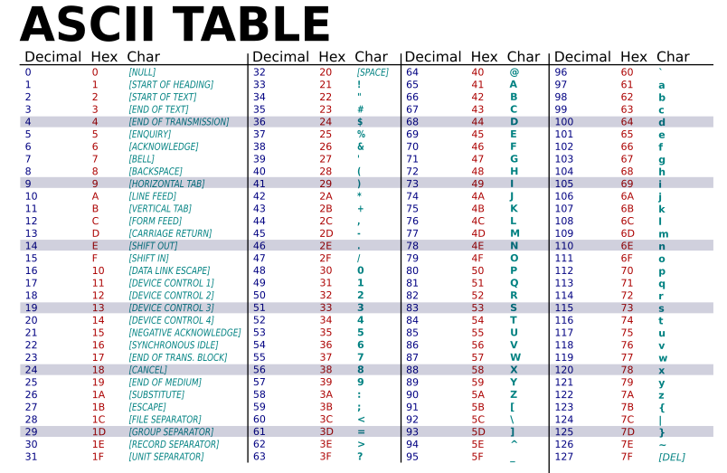
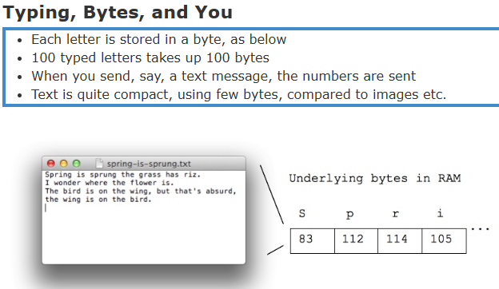
- One byte works well for individual characters, but computers are also good at manipulating numbers.
- Integers are typically stored with either 4 or 8 bytes
4 bytes can store numbers between -2147483648 and 2147483647
8 bytes can store numbers between -9223372036854775808 and 9223372036854775807
- Adding in binary is just like normal addition with carrying
But when you run out of bits you can't carry anymore
Leftmost bit indicates sign, so carrying to the leftmost bit changes a number from positive to negative.
So adding 1 to 2147483647 goes to -2147483648!
Called Integer Overflow

6. Word and Double word
Finally number of base-2 representation are grouped to form byte, word and double word.
8 bits makes 1-byte byte
1101 0010
8-bits =1-byte =

16 bits makes 1-word word
0000 0010 1101 0010
16bits = 1 word

32 bits makes 1-double word double-word.
32bits = 1 double word
0000 0000 0000 0010 1101 0010

Like byte, even word, double word has limit on maximum value (range of numbers) that it can store.
Hence the range of byte, word and double word is shown below table.
 | Range | Range in hexa-decimal
nibble
byte | 0 -to- 255 | 0x00 -to- 0xFF
word
Double-word

7. Number system.
Any numerical value (number) can be represented in any of the following number system.
- Base 10 are decimal system.
- Base 2 are binary system.
- Base 16 are Hexa-decimal numbers.
Number Base | Full Text Notation (number system)
Base 2 | binary
Base 8 | octal
Base 10 | decimal
Base 16 | hexadecimal

Base-10:
The most familiar representation of number is in base 10 systems. Eg 12345. This number requires only 4 digits to represent a number.

Base-2:
The common representation of a positive integer in computer is a string of bits, using the binary numeral system (Base-2).

Hexa-decimal number (Base-16):
Since computer stores values in 0 and 1’s. Any number has to be converted to base-2 representation. Base-2 requires more digits. Example to represent 1234 it requires 1011010010. Thus, it is error prone and tedious.
So base-16 (Hexadecimal) is convenient shorthand notation to talk about binary numbers stored in computers. The primary use of hexadecimal notation is as a human-friendly representation of binary-coded (base-2) values in computing and digital electronics. Hexadecimal is also commonly used to represent computer memory addresses.

Hexadecimal is a number system that uses 16 symbols to represent numbers. It's often used in computer science to represent binary data in a compact way.
How it works
- Hexadecimal uses the symbols 0–9 to represent the values 0–9.
- It uses the letters A–F to represent the values 10–15.
- Each digit represents a decimal value. For example, D is equal to 13 in base 10.
- Hexadecimal numbers can be converted to other number systems, such as binary, octal, and decimal.

Note: Different patterns can be made with 1, 2, or 3 bits. Note from 4 bits, 16 patterns can be derived. So binary number are grouped in 4 bits to convert to Hex decimal number.
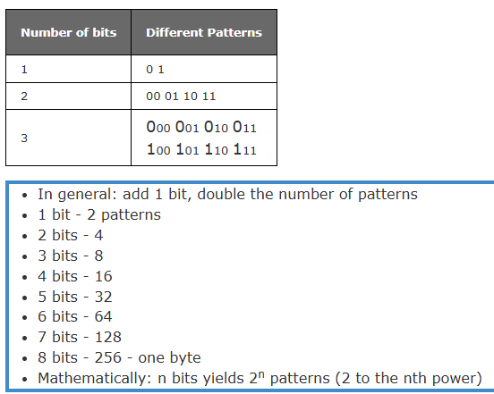

Replace every hex symbol with 4 bit binary representation of the hex digit.
Digit value | Hex symbol | Binary pattern
0 | 0 | 0000
1 | 1 | 0001
2 | 2 | 0010
3 | 3 | 0011
4 | 4 | 0100
5 | 5 | 0101
6 | 6 | 0110
7 | 7 | 0111
8 | 8 | 1000
9 | 9 | 1001
10 | A | 1010
11 | B | 1011
12 | C | 1100
13 | D | 1101
14 | E | 1110
15 | F | 1111

Conversion between number system
Decimal to Hexa-decimal conversion | Hex to decimal conversion
Identify the group of 4 bits each. Fill the partial group with 0’s on outside. Then replace each group by corresponding hex digit. | hexadecimal number (Base-16) 0x2AF3 is equal to 10,995 decimals (base-10).
  0011 | 1010 | 0101 | 0110 | . | 1110 | 0010 | 1111 | 1000
  3 | A | 5 | 6 | . | E | 2 | F | 8
  Base-16 | 2 | A | F | 3
  base-16 to base-10 | 2×16³ | A×16² | F×16¹ | 3×16⁰
  base-16 to base-10 | 2×16³ | 10×16² | 15×16¹ | 3×16⁰
  base-16 to base-10 | 2x4096  =8192 | 10x256  =2560 | 15x16  =240 | 3*1  =3
  Base-10 | 10,995

Phase 4 - Working with Git and Bash commands - Local Repo
- Working with Git Bash commands
Getting Started Git Bash commands: https://typoapp.io/blog/git-bash-commands
These commands are used in Git bash terminal to navigate in the Git repo. So, practice these commands as these are very necessary.
Important Git Bash commands in snapshot.
File Management
# Create a new directory
mkdir new-project

# Create a new file
touch README.md

# Copy files
cp original.txt copy.txt
cp -r source-folder/ destination-folder/ // Copy directory

# Move or rename files
mv oldname.txt newname.txt
mv file.txt /path/to/destination/

# Delete files and directories
rm unwanted.txt
rm -rf old-directory/ // Be careful with this!
Directory Navigation
# Show current directory
pwd
# List files and directories
ls
ls -la // Show hidden files and details
# Change directory
cd project-folder
cd .. // Go up one level

- Working with Git commands
Important Git local Repository Management Commands in snapshot.
Creating and Cloning Repositories
# Initialize a new repository or Setup Git in development (working) folder
git init
# Clone an existing repository
git clone https://github.com/username/repository.git
# Clone to a specific folder
git clone https://github.com/username/repository.git custom-folder-name
Tracking Changes
git status //Check repository status
git add filename.txt // Add specific file
git add . // Add files to staging area (all changes in folder)
git add *.js // Add all JavaScript files
git add src/ // Add entire directory
git commit -m "Add user authentication feature" // Commit changes
git commit --amend -m "Updated message" // Amend the last commit
Viewing History
git log // View commit history

Important Git Branch Management Commands in snapshot.
Branching is where Git's power truly shines, allowing parallel development streams.
Branch Management
git branch // Local branches
git branch -r // Remote branches
git branch -a // All branches
git branch feature-login // Create a new branch
git checkout -b feature-payment # Create and switch to a new branch
git checkout main // Switch branches
git branch -m old-name new-name // Rename a branch
git branch -d feature-complete // Delete a branch
git branch -D feature-broken // Force delete

Syncing with Remotes
git push origin feature-branch // Upload local changes
git branch --set-upstream-to=origin/main main // Set up branch tracking

- Git workflow
  - Navigate to the directory where you want to use Git
$ mkdir test , $cd test

  - Initialize new repository
When working with Git, people often mention Git repository, short form as repo. Earlier we installed Git, that doesn’t mean we can use it. We need to manually tell machines when to use Git and in which directory. We need to create a Git repository in the directory where we need to use Git. So, Git starts saving history in the directory after Git repo is set up.
Use git init to create a new git repository. Before we can do anything git-related, we must initialize a repo first!. This is something you do once per project. Initialize the repo in the top-level folder containing your project. Git tracks the directory and all nested directories.
More information on Git init command can be found at www.git-scm.com/docs/git-init
$ git init
  - Create feature branch
$ git checkout -b feature-payment

  - Make changes in initialized folder and check status
Git is Watching Us after init command. Try making a new file in your repo and then run git status again. You'll see that git noticed the file, but it is "untracked. gives information on the current status of a git repository and its contents.
More information on Git init command can be found at www.git-scm.com/docs/git-status
$ git status
  - Stage the changes
$ git add . // add dot says that group all the changes done in current and nested project directory.

  - Create checkpoint
“Commit” command will add check point to the history saved in “. Git” folder with a message to refer.
$ git commit “your message for checkpoint reference.”

  - Push changes to remote branch
$ git push <remote> <branch>

Phase 5 – Create remote Repo

How do I get my code on Github
How do I get the local Git repo to GitHub. How do I connect them and How do I setup GitHub repo and what do I do on my machine to tell about GitHub repo. There are 2 different approaches to do this.

Option 1: Existing Repo
If you already have an existing repo locally that you want to get on GitHub.
- Create a new repo on GitHub.
- Connect your local repo (add a remote)
- Push up your changes to GitHub.

Option 2: Start From Scratch
If you haven't begun work on your local repo, you can...
- Create a brand-new repo on GitHub.
- Clone it down to your machine.
- Do some work locally.
- Push up your changes to GitHub.

Pushing: To get your own changes and Git history up on GitHub, we need to PUSH them up. The typical workflow looks like this:
- Make some changes locally.
- Add and commit to those changes.
- Repeat...
- Push new commits up to GitHub.

Option 1
Option 1
Move the local Git repo to empty GitHub branch. Perform $ git log
…….. lot of commits get displayed. All these history and code/work will be moved to GitHub.
Step 1: Create a new repo on GitHub | - Sign in on GitHub.  - In the upper-right corner of page next to profile picture, click “+ - > New Repository.”  - In new page, enter the Repository name under “Create a new repository.”  - Enter “Description”  - Mark it as public or private. If it’s your website, mark it as private, otherwise anyone can make changes to the website.  Now we have done empty repository on GitHub. Local repo doesn’t know anything about it.
Step 2: Give a name to GitHub url and set that name in the local Git repo. | Before we can push anything up to GitHub, we need to tell Git about our remote repository on GitHub. We need to set up a "destination" to push up to. In Git, we refer to these "destinations" as remotes. Each remote is simply a URL where a hosted repository lives.  To view any existing remotes for you repository, we can run git remote or git remote -v (verbose, for more info)  $ git remote -V  This just displays a list of remotes. Since we have not yet set the remote, this command will not show anything.  Adding A New Remote: A remote is really two things: a URL and a label. To add a new remote, we need to provide both to Git.  $ git remote add <name> <url>  Ex: $ git remote add origin www.bhal.com //Tells Git anytime name "origin" is used, it’s referring to this particular GitHub repo URL.  Remember, by setting up a remote we are just telling Git about a remote repository URL. We have not "communicated" with the GitHub repo at all yet.
They are not commonly used, but there are commands to rename and delete remotes if needed.
git remote rename <old> <new>
git remote remove <name>
Step 3: Push changes to remote GitHub |  | Now that we have a remote set up, let's push some work up to GitHub! To do this, we need to use the git push command. We need to specify the remote we want to push up to AND the specific local branch we want to push up to that remote.  $ git push <remote> <branch>  Ex: $ git push origin master //tells git to push up the local-master branch to our origin remote. For the first time, there are no branches on remote. It creates a master branch. From next time, this command pushes local-branch to remote-master by default.  But if we don’t want to push to remote-master  $ git push origin <local-branch>: <remote-branch>  $ git switch -c cats  $ git push origin cats:master // This pushed cats to matser branch
-u option allows us to set the upstream of the branch we are pushing. You can think of this as a link connecting our local branch to a branch on GitHub. Running $ git push -u origin master sets the upstream of the local master branch so that it tracks the master branch on the origin repo. Local Git remembers it for future push commands.
Now that it remembers, do some changes and commit.
$ git switch -c dogs
$ git push -u origin dogs
$ git touch dogs.txt
$ git commit -m “text push”
$ git push // changes are pushed to existing dogs branch, not to matser.
Step 4: Check GitHub repo |  | Check the recent commits with time reflecting on GitHub. Check “All commits” page.

Option 2 - Git clone
Connecting GitHub repo to local repo
So far, we've created our own Git repositories from scratch, but often we want to get a local copy of an existing repository instead. This opens the path for collaboration and exposure. Or you haven’t started your work locally. You know you want to use GitHub. You can start creating empty repo on GitHub and clone it back to local machine. This automatically configure remote. Then do some work and push changes to GitHub repo.
To do this, we can clone a remote repository hosted on GitHub. All we need is a URL that we can tell Git to clone for use. To clone a repo, simply run git clone <url>. Git will retrieve all the files associated with the repository and will copy them to your local machine. In addition, Git initializes a new repository on your machine, giving you access to the full Git history of the cloned project. Make sure you are not inside of a repo when you clone!. For more information refer : www.git-scm.com/docs/clone
$ git clone https://github.com/...
// Do some changes.
$ git diff
$ git push origin master
Anyone can clone a repository from GitHub, provided the repo is public. You do not need to be an owner or collaborator to clone the repo locally to your machine. You just need the URL from GitHub. You need permission to push up your own changes to the GitHub repo.
url for cloning can be copied from project path as shown below.

